Malmesbury Branch Railway Line

Summary
Branch Line operated 1877 to 1962

Location
Gloucester Road Station Malmesbury to Dauntsey, later to Little Somerford
County: Wiltshire
Parish: Various
Description
Malmesbury Branch Railway Line opened in 1877 after several earlier proposals and early work carried out in 1865. The railway was part funded by Malmesbury Railway Company but worked by Great Western Railways (3) who employed the staff and owned all rolling stock. It ran from Gloucester Road, Malmesbury to Dauntsey Junction until 1933 when the route was changed to join up with the line through Little Somerford.

Between Dauntsey and Malmesbury was a station at Great Somerford and 4 level crossings. The line entered the parish of Malmesbury under the Malmesbury – Wotton Bassett Road at Cowbridge, from here the line continued westwards on an embankment above the River Avon. The track then passed into a steep-sided cutting before re-crossing the Avon and a tributary via two bridges and entering a 105 yard long tunnel (1). After the tunnel the Avon as crossed again before Lovers Lane Crossing, just before entry to the station yard (4).

For most of the period of operation the line was worked by ‘517’ class locomotives typical of Great Western local services. The ‘one engine in steam’ principle was always used with a white train staff, without which no train could proceed (1). Pre 1933 the service was provided by three carriages, built in Swindon in the late 1880s, with 1st, 2nd and 3rd class accommodation. There were at least 6 trains a day Monday to Saturday and the town saw great benefits, in particular the growth in market trade. The first half yearly accounts in 1878 showed 23,766 passenger, 4,819 head of cattle and 5,727 tons of goods carried.

In 1933, as a cost cutting measure, the route of the branch line was changed. In 1903 a new rail route to South Wales going through Little Somerford was opened. Thirty years later the obvious step was taken to join the line to Malmesbury at this point and the station at Great Somerford closed.
After railway nationalisation in 1948 trade declined and in 1950 a 50% loss of patronage since 1938 was reported (1). There were attempts to keep the line open but on 10th September 1951 it closed to passenger traffic. Over the previous year only 3 trains had run daily and averaged 5 passengers (2). The goods service continued until 11th November 1962 when the line closed.
Today the tunnel can still be seen from the public footpath below St. Joseph’s School, there are interpretation boards in the Conygre Mead nature reserves pointing out the route and the newly opened (2017) Cowbridge to Malmesbury footpath uses part of the old railway embankment.
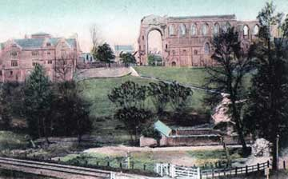
Lovers Lane Crossing in Malmesbury, date unknown.
Photograph Athelstan Museum, Malmesbury

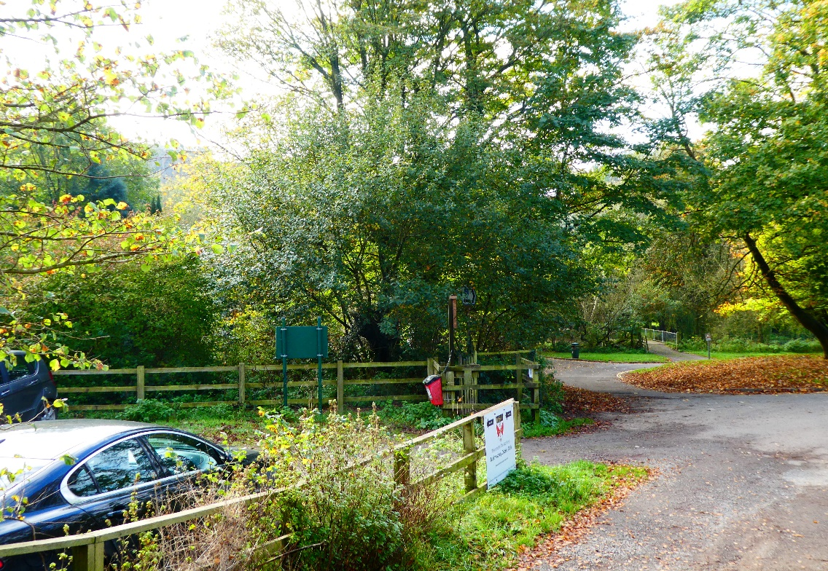

As near as we can get to the same picture with the Abbey just visible in the background, 2017. Image M J Goodyer

Selected Sources

- D.M. Fenton, 1977. The Malmesbury Railway, Oakwood Press, Dorset.
- http://www.athelstanmuseum.org.uk/todays_transport_rail.htmlCivic Trust.
- http://www.wiltshire-opc.org.uk/Items/Malmesbury/Malmesbury%20-%20The%20Malmesbury%20Railway.pdf
- Lost Malmesbury – Malmesbury Railway Station

Map of Malmesbury Branch Railway– Copyright source (1).

